METRO/URBAN INSTITUTIONS: IT’S ABOUT BELONGING 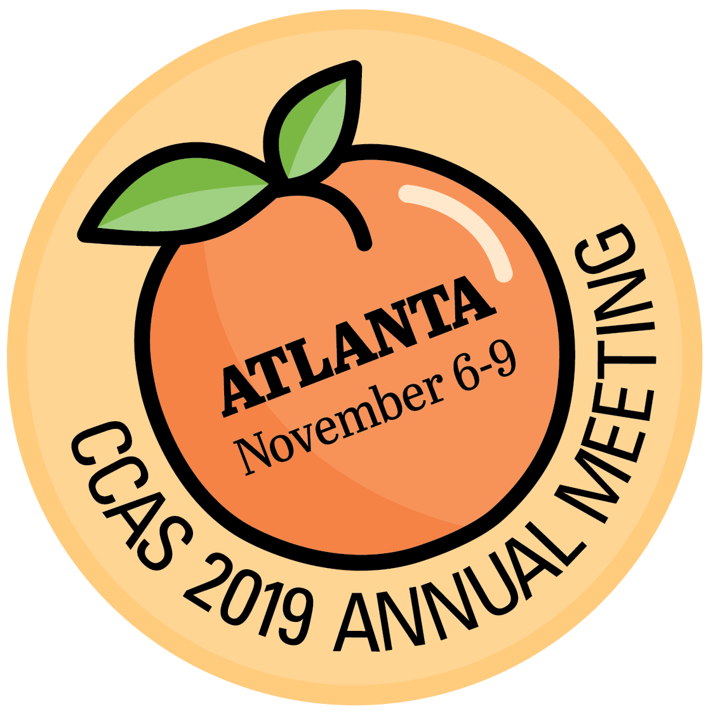
Building Community and Sense of Belongingness at Your Institution

 | Connecting with the External Community | Community/Belongingness for Students | Community/Belongingness  for Faculty and Staff
What are you already doing and how can you build on it?

What resources can you leverage to create a greater sense of community?

What can you do to create community with little to moderate investment?

What are the greatest challenges you face in building community and how can you overcome them?

What are some opportunities you have that you are not taking advantage of to build community?

